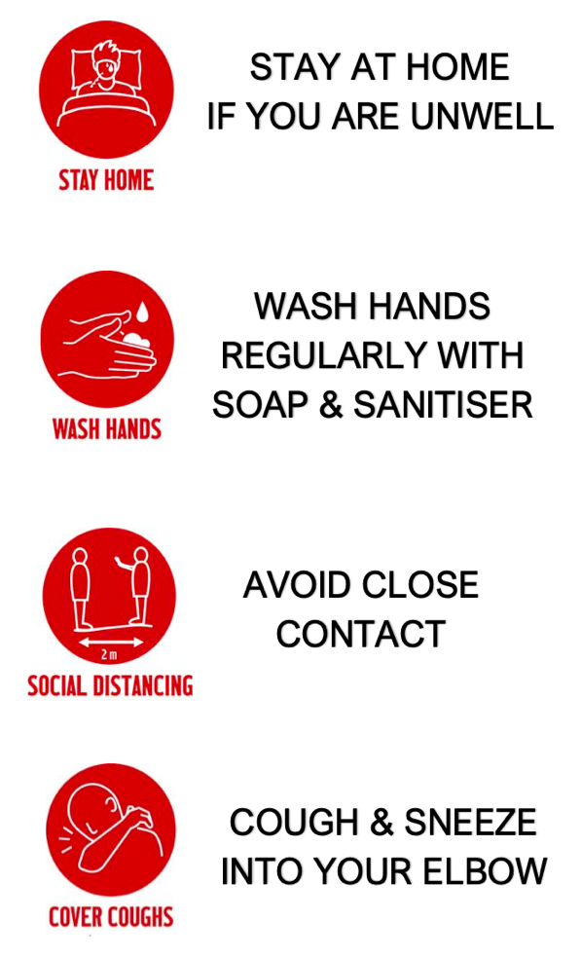

**INTRODUCTION**

CSSA has developed the following guidelines to ensure that our school sports events are a COVID safe environment for all of our students, teachers, coaches, managers, officials and spectators.

These guidelines are based on the best available evidence and advice to optimise participant and community safety and will be used in conjunction with the directives and guidelines of the Federal and State Government. We have also sought advice from the Association of Independent Schools and the NSW School Sport Unit.

Our guiding principles behind these guidelines are to:

* Keep our Community safe;
* Align with the policies and directions of our State and Federal Government; and
* Maintain a level of consistency throughout our Schools and Community.

The priority must always be the preservation of public health and minimisation of the risk of community transmission. All CSSA participants (this includes players, parents/guardians, coaches, officials, volunteers, spectators and administrators) must play a role in helping to slow the spread of COVID-19.

The guidelines outlined within this document may be modified as we, as a Community return to the ‘new’ normal, but there may also be some more specific guidelines relevant to specific sports or venues dependant upon respective COVID Safe Plans.

Your cooperation is appreciated

Linda Heslehurst

CSSA Executive Officer

M: 0418 685 898

CSSA SPORT

Hygiene Protocols



Christian Schools Sports Association

**COVID SAFE GUIDELINES**



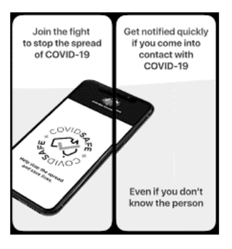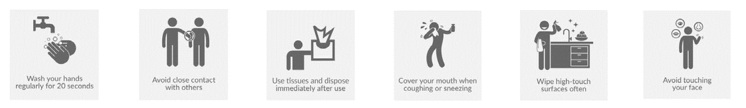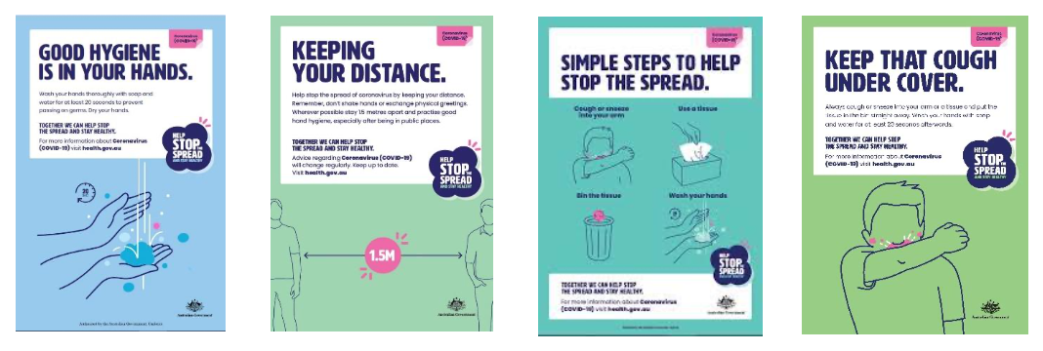

**GUIDELINES FOR ALL CSSA EVENTS**

* Ensure a Risk Assessment has been completed prior to any Trial/Event;
* A COVID Safety Officer will be present at all CSSA Trials/Events........this person must have completed the COVID-19 Infection Control Training provided by the Australian Government - <https://www.health.gov.au/resources/apps-and-tools/covid-19-infection-control-training>
* An attendance register for all trials/events will be recorded and filed for 28 days;
* Limit the number of spectators attending trials/events to ensure social distancing guidelines of 1.5m are adhered to;
* Recommend that spectators and officials wear a **face mask** when unable to physically distance, particularly at indoor events to keep everyone safe;
* Recommend that all participants and officials have their own **clearly labelled** water bottle and towel;
* Provide hand sanitizer on entry and exit to all venues, as well as pre, during and post trials/events for participants and officials;
* Ensure that there are Hygiene Stations in designated areas – i.e. team benches, score-benches, First Aid etc;
* Ensure all equipment is cleaned, disinfected before, during and after competitions;
* Strongly encourage all participants to shower prior to and after competitions (preferably at home);
* Limit unnecessary social gatherings – allow additional time in between matches/events to minimize large congregations where possible;
* At events where merchandise will be sold only cashless transactions will take place;
* Participants / officials and spectators **DO NOT ATTEND IF THEY ARE FEELING UNWELL** (includes any signs/symptoms of cold, flu, or any other illnesses);
* Actively promote the downloading of the COVID-safe app for their smartphone;



Christian Schools Sports Association



* Any uniforms/bibs to be laundered need to be placed into a laundry bag by the individual – these items need to be washed after each use;
* There is to be no sharing of whistles – each official must have their own whistle;
* Participants and officials should depart the venue as soon as possible following the completion of their trial or competition event;

**SPECIFIC GUIDELINES FOR SPECTATORS**

* All spectators will be required to sign-on to an Attendance Register on arrival at any trial or competition event;
* All spectators will be required to adhere to the social distancing guidelines of 1.5m where possible – people from same household are not required to distance;
* It is strongly recommended that spectators wear a **face mask** when unable to physically distance, particularly at indoor events to keep everyone safe;
* Spectators will not be permitted to enter designated change-rooms allocated to the athletes / competing teams;
* Currently for training and competition it is recommended that 1 x Parent / Care-giver attend (no non-participating siblings etc);

**SPECIFIC GUIDELINES FOR ATHLETES / COACHES & OFFICIALS**

* Arrive at the venue dressed and ready to compete or officiate social distancing guidelines of 1.5m;
* Athletes, coaches and officials must not spit – any need to spit must be done into a tissue or bin for easy disposal;
* Physical greetings and celebrations should be discouraged – i.e. hugging, kissing, handshakes, high fives etc;
* Maintain high levels of hygiene if wearing a mouthguard – limit touching and sanitize regularly;
* Wherever possible bring your own equipment – i.e. Cricket (Bat, Pads, Gloves, Helmet);



Christian Schools Sports Association



In saying this CSSA will address the following:

* All venues and facilities utilized by CSSA have adopted a COVID-19 Safety Plan;
* Specific guidelines in reference to facilities and venues will be covered off within the respective Event Information located on the CSSA website - i.e. control measures, maximum crowd capacity etc;
* A COVID-19 Safety Official is present at all trials and competition events to assist with registration, social distancing and hygiene;
* Routing for entry and exit points to be clearly sign-posted for all indoor venues;
* Physical social distancing indicators to be displayed at all indoor and outdoor venues;
* The use of visual aids throughout facilities to encourage good hygiene practices and to assist in ‘stopping the spread’;
* Toilets, change-rooms, team areas and equipment has been thoroughly cleaned prior to the commencement of any trials / competition events and that these standards are maintained throughout the event...bathrooms to be fully equipped with soap and paper towel;
* Hand sanitizer is available on arrival and departure and that there are multiple sanitizing stations located in and around the Facility;

**GUIDELINES FOR FACILITIES**

Given that all CSSA Trials and Competition Events are conducted at external venues / schools not managed by CSSA we will be expected to operate within their respective guidelines and jurisdictions.

**EXAMPLES OF FACILITY SIGNAGE**

Christian Schools Sports Association

